**ME 306 Project Report**

**Rhino XR3**

**Group Members:-**

**1) Mayank Bharti - 210003047**

**2) Vinay Desai - 210003084**

**3) Saurabh Shukla - 210003067**

**4) Arham Azam - 210003046**

**5) Rajnesh Meena - 210003061**

**6) Aryan Kulkarni - 210003016**

**7) PrassanaKante - 210003054**

**8) Shivam Jain - 210003070**

**9) Pulkit Gupta - 210003058**

**10) ChinmayDawalbaje - 210003026**

**11) Sandeep Singhania– 210003067**

**Rhino-XR3 [Five Axis Articulated Robot] :-**

**This Class of robots includes both the Rhino XR3 educational robot and the Alpha II industrial robot as special cases. The Rhino XR3 robot is shown in fig given below.**

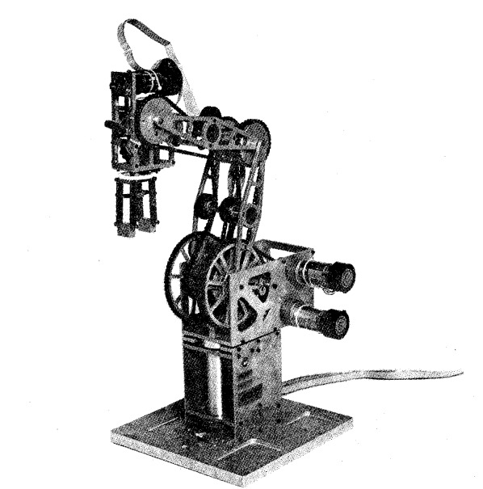

**The physical structure of the Rhino XR-3 is such that the base motor is mounted vertically and remains fixed, while the shoulder, elbow, and tool pitch mo- tors are mounted horizontally on the body, which rotates about the base axis. The tool roll and tool closure motors are smaller motors mounted in the hand.**

**The Servo Control Loop :-**

The Rhino uses a closed loop encoder system that works well when adjusted correctly. First is the encoder wheel. As the wheel turns it feeds data to the controller. From this data the controller determines if thecorrect position. Lets say the motor has turned when it was not supposed to. The controller would turn the motor on in the opposite direction to return it to the desired position This is fine expect the encoder now has gone to far in the other direction.

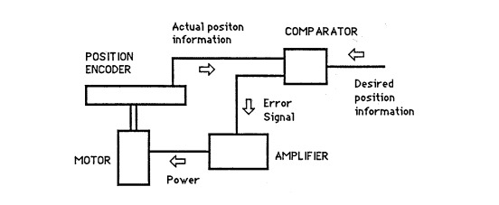

The Figure above shows basic control loop of servos. A feedback system that consists of a sensing element, an amplifier and a servomotor used in the automatic control of a mechanical device.

**The Link-Coordinate Diagram :-**

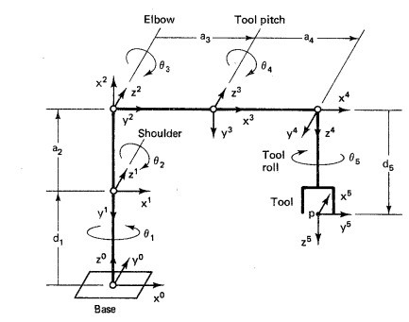

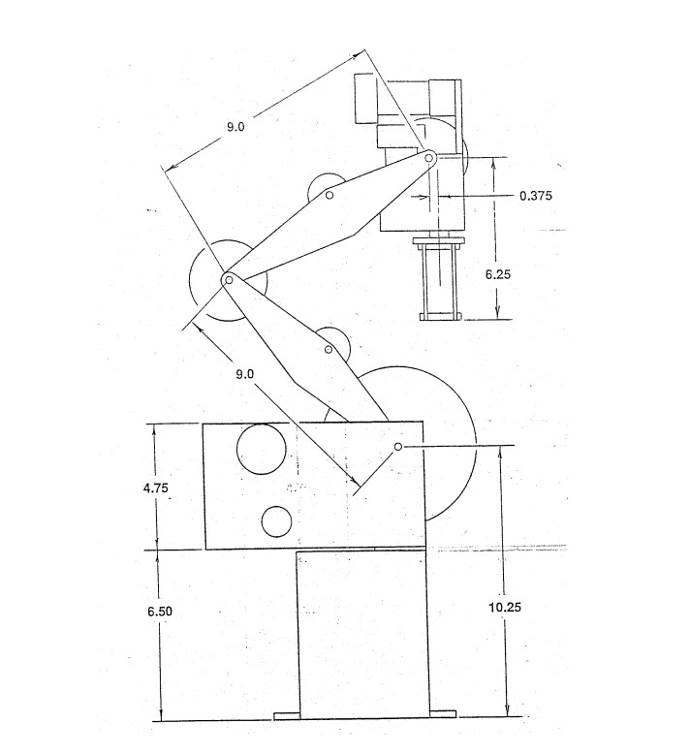

**Link Coordinate :**

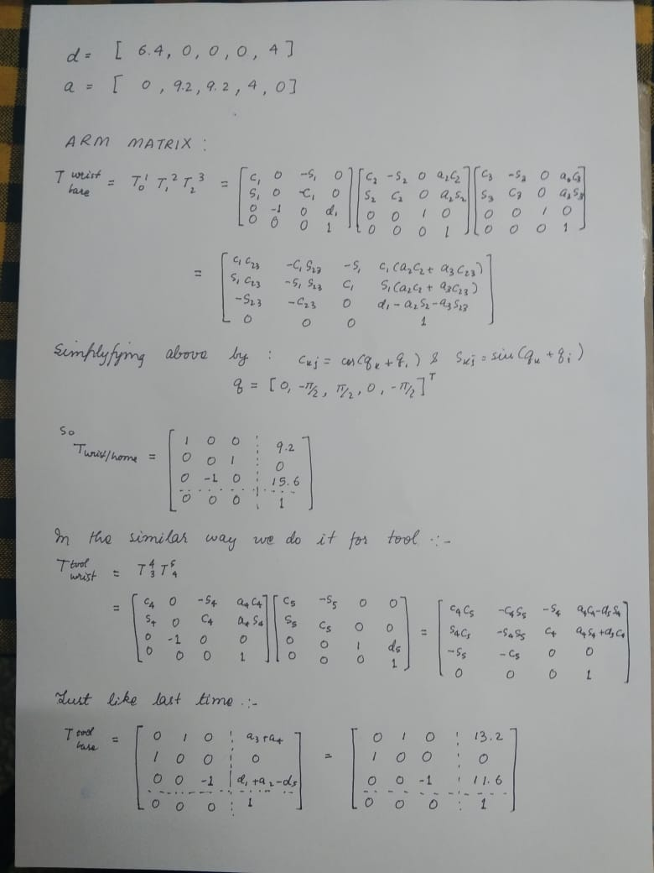

**Stress Analysis:-**

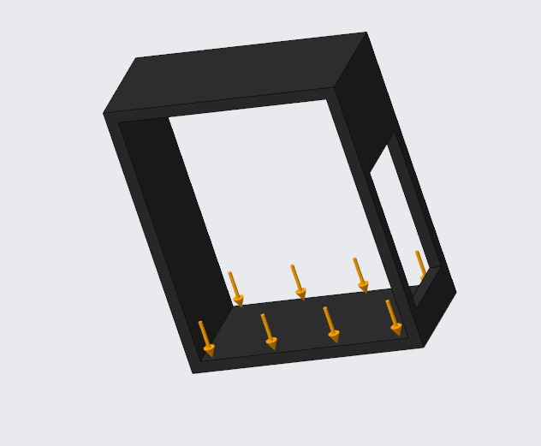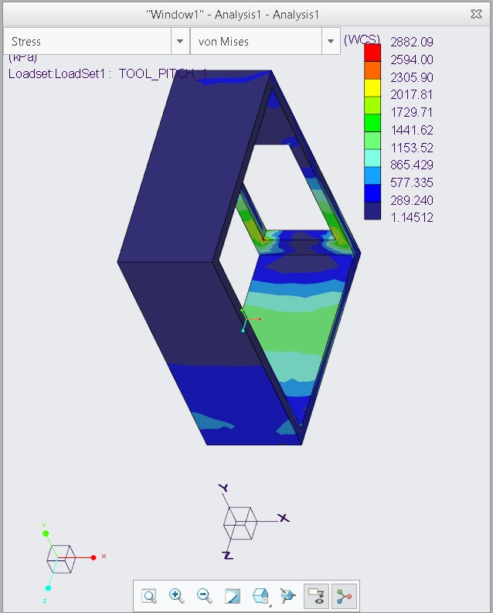

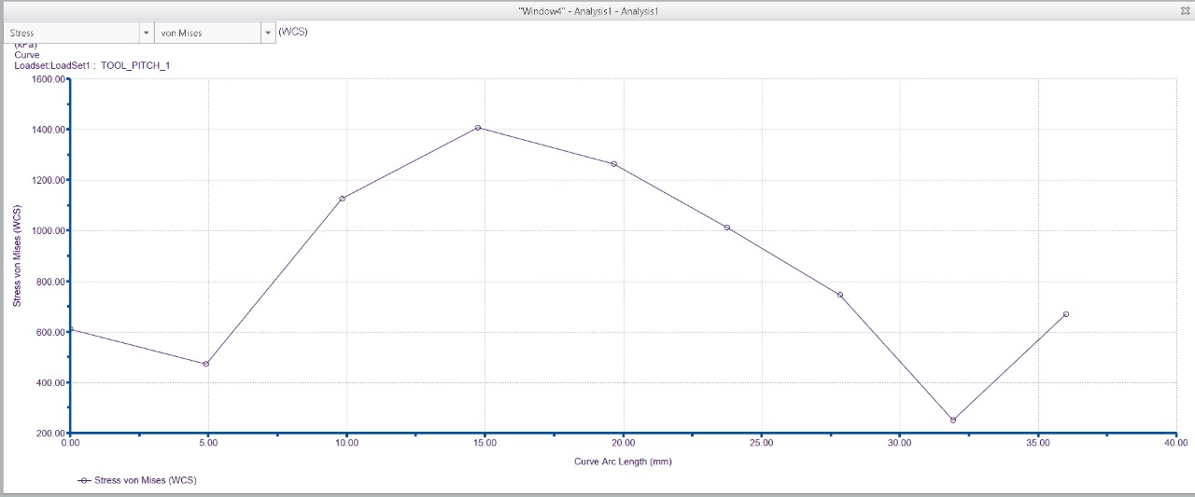

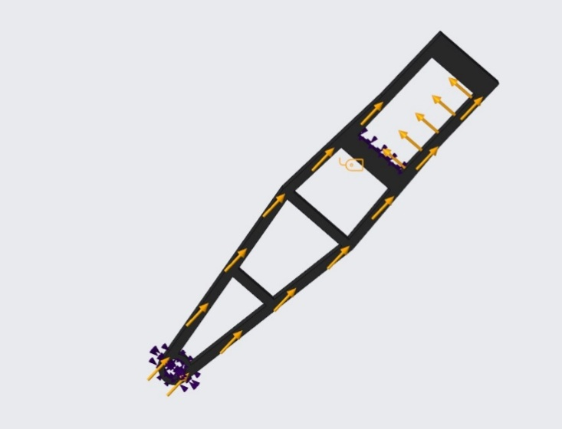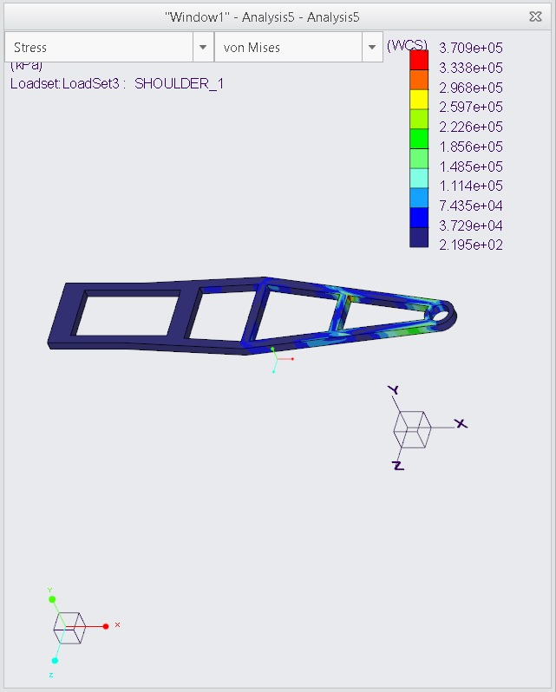

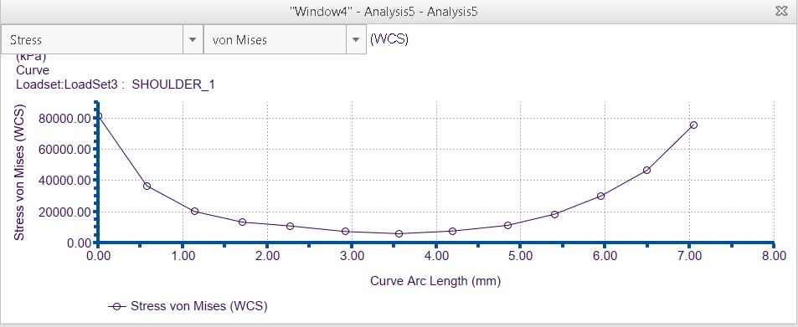

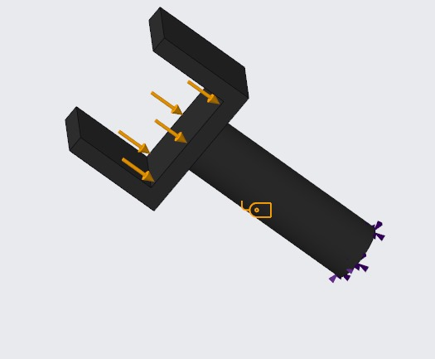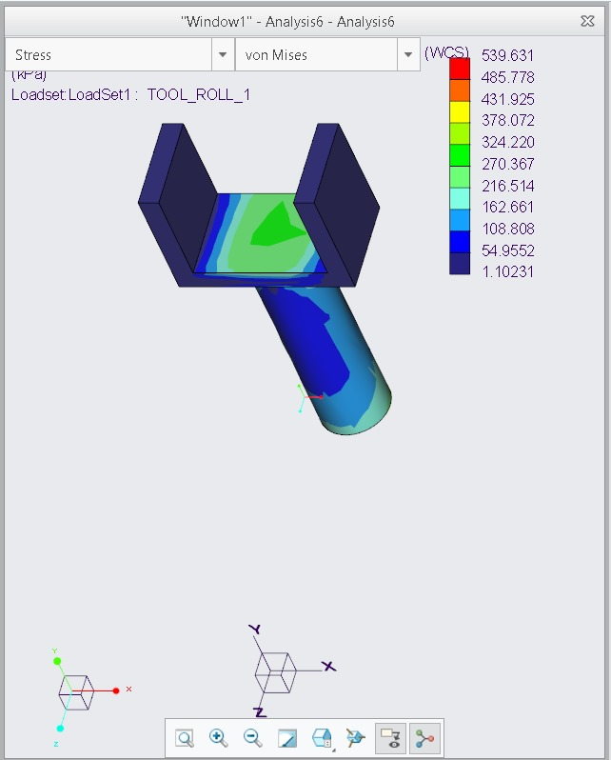

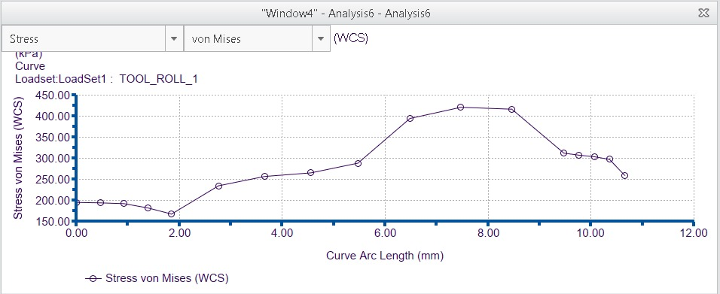

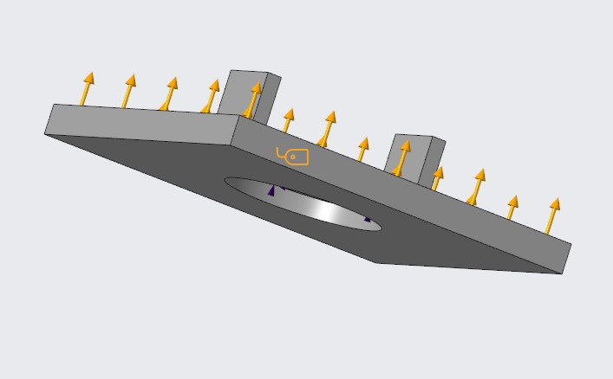

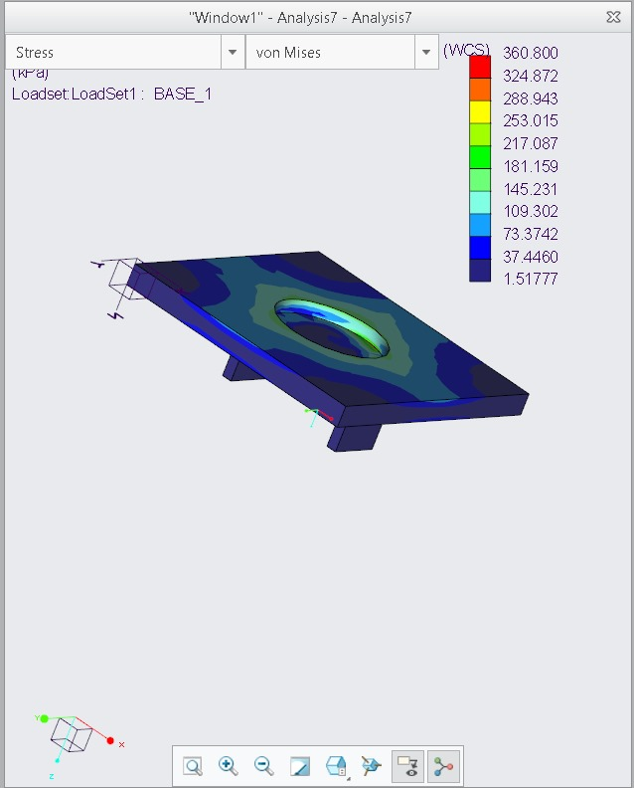

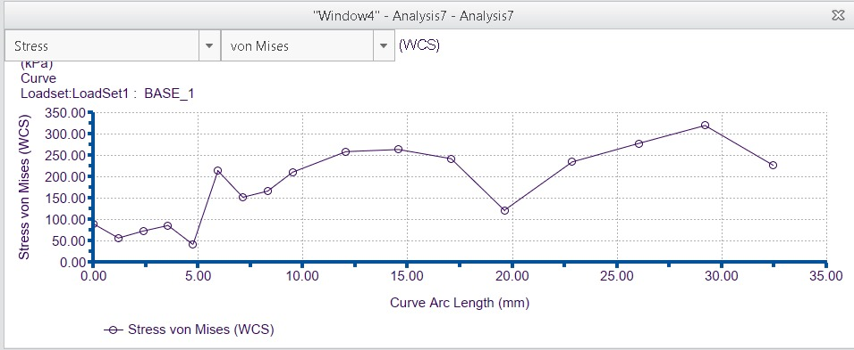

**Rhino XR-3 Model :**

**Simplified Version:**



**Compact Model:**

